

Mohammad Ali Jinnah University

Chartered by Government of Sindh - Recognized by HEC

**Assignment 3**

**Name:** Muhamad Fahad

**Id:** FA19-BSSE-0014

**Subject:** Software Engineering Lab (CS 3111)

**Section:** CM

**Teacher:** Sir Abdul basit

**Date:** Sunday, December 27, 2020

* **Draw Class diagram for given scenario (**hockey league**) (**7 points**).**

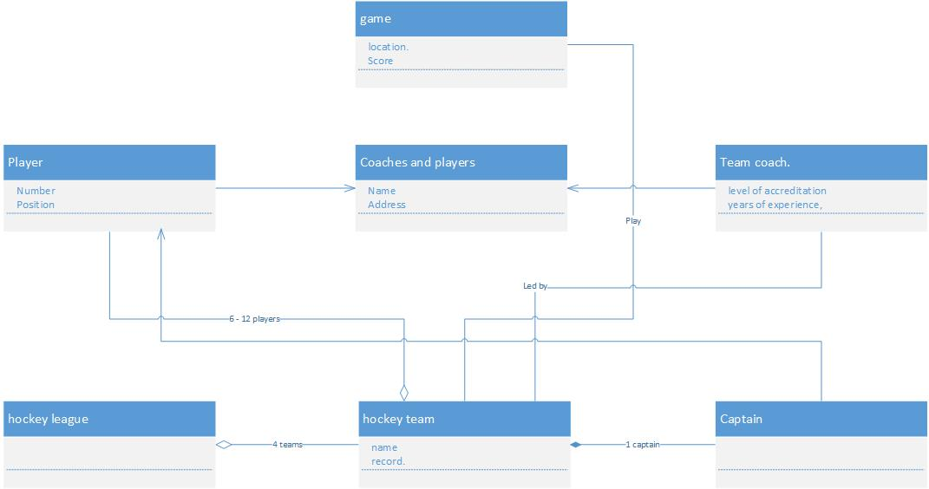

* **Draw Class diagram for given scenario (**SABIC**) (**8 points**).**

